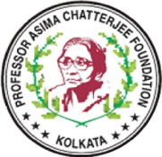

International Conference on Chemistry for Human Development (ICCHD-2026)
Date: 10th-12th January, 2026, Venue: Science College, CU, Kolkata-700009

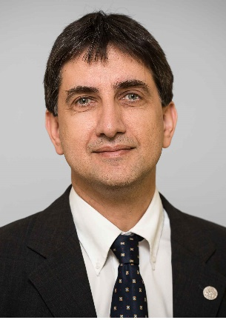

Prof. A. Stephen K. Hashmi, Heidelberg University, Germany

Professor A. Stephen K. Hashmi obtained his Ph.D. in 1991 from LMU Munich under the guidance of ProfessorG. Szeimies. After postdoctoral studies with Professor B. M. Trost at Stanford University (1991-1993), he started his independent career with Prof. J. Mulzer at Free University of Berlin, University of Frankfurt and University of Vienna, he obtained his Habilitation from Frankfurt University and was visiting Scientist at the University of Tasmania.After Professorships at Marburg University and Stuttgart University (Associate Professor), he became Full Professor at Heidelberg University in 2007.
Visiting Professorships at Gakushuin University (Tokyo, Japan, 2008), at Milan University (Milan, Italy, 2010), Tokyo Institute of Technology (Tokyo, Japan, 2012) and Keio University (Tokyo, Japan, 2015).
Awards:
Dr. Otto Röhm Memorial Fellowship
Karl-Ziegler Memorial Fellowship
ORCHEM Prize for natural sciences of the German Chemical Society
Hector Research Prize 2010

