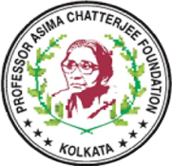    

|  |
| --- |
| **International Conference on Chemistry for Human Development (ICCHD-2025)**  **Date: 4th-6th January, 2025, Venue: Science College, Calcutta University, Kolkata** |

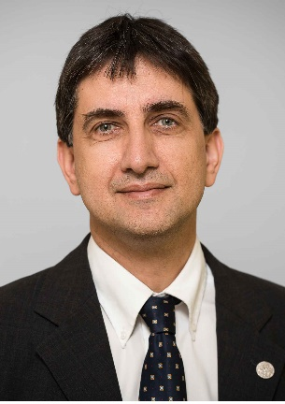

**Prof. A. Stephen K. Hashmi, Heidelberg University, Germany**

**Professor A. Stephen K. Hashmi** obtained his Ph.D. in 1991 from LMU Munich under the guidance of ProfessorG. Szeimies. After postdoctoral studies with Professor B. M. Trost at Stanford University (1991-1993), he started his independent career with Prof. J. Mulzer at Free University of Berlin, University of Frankfurt and University of Vienna, he obtained his Habilitation from Frankfurt University and was visiting Scientist at the University of Tasmania.After Professorships at Marburg University and Stuttgart University (Associate Professor), he became Full Professor at Heidelberg University in 2007.

Visiting Professorships at Gakushuin University (Tokyo, Japan, 2008), at Milan University (Milan, Italy, 2010), Tokyo Institute of Technology (Tokyo, Japan, 2012) and Keio University (Tokyo, Japan, 2015).

Awards:

Dr. Otto Röhm Memorial Fellowship

Karl-Ziegler Memorial Fellowship

ORCHEM Prize for natural sciences of the German Chemical Society

Hector Research Prize 2010